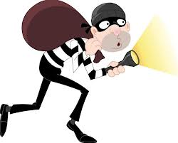
The Elements of THIEVES

Name: _________________________________________

Title

What is the title?

What do I already know about this topic?

What does this topic have to do with the preceding chapter?

Does the title express a point of view?

What do I think I will be reading about?

Headings

What does this heading tell me I will be reading about?

What is the topic of the paragraph beneath it?

How can I turn this heading into a question that is likely to be answered in the

text?

Introduction

Is there an opening paragraph, perhaps italicized?

Does the first paragraph introduce the chapter?

What does the introduction tell me I will be reading about?

Do I know anything about this topic already?

Every first sentence in a paragraph

What do I think this chapter is going to be about based on the first sentence in

each paragraph?

Visuals and vocabulary

Does the chapter include photographs, drawings, maps, charts, or graphs?

What can I learn from the visuals in a chapter?

How do captions help me better understand the meaning?

Is there a list of key vocabulary terms and definitions?

Are there important words in boldface type throughout the chapter?

Do I know what the boldfaced words mean?

Can I tell the meaning of the boldfaced words from the sentences in which they

are embedded?

End-of-chapter questions

What do the questions ask?

What information do they earmark as important?

What information do I learn from the questions?

Let me keep in mind the end-of-chapter questions so that I may annotate my text

where pertinent information is located.

Summary

What do I understand and recall about the topics covered in the summary?

